# How to authentication web page using JWT token in ASP.NET Core

## Introduction

This sample demonstrates how to authentication web page using JWT token in ASP.NET Core.

## Sample prerequisites

* Visual Studio 2017 or above. [[Visual Studio Home Page](https://www.visualstudio.com/)]
* Visual Studio enabled ASP.NET Core develop component.

## Building the sample

Use Visual Studio to open the sample solution **CSJWTAuthWebPageASP.NETCore**, then press **F6 Key** to build the sample project.

## Running the sample

* Use Visual Studio to open the sample solution **CSJWTAuthWebPageASP.NETCore**, then press F5 Key or select **Debug -> Start Debugging** from the menu.
* When the project is running, you will see below page in browser.

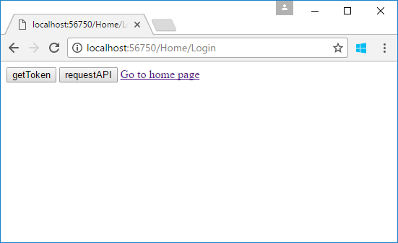

* Click **getToken** button.

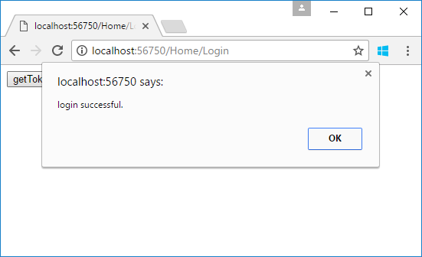

* Then you can visit the authorize web api and web page.
* Click the **requestAPI** button.

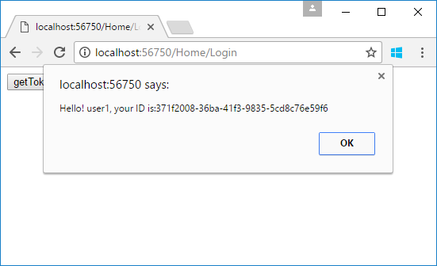

* Click **Go to home page** link.

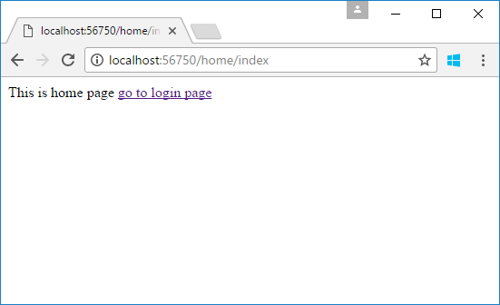

## Using the code

When generate token, should add the token to cookie.

public JsonResult Get(User user)

{

var existUser = UserStorage.Users.FirstOrDefault(u => u.Username == user.Username && u.Password == user.Password);

if (existUser != null)

{

var requestAt = DateTime.Now;

var expiresIn = requestAt + TokenAuthOption.ExpiresSpan;

var token = GenerateToken(existUser, expiresIn);

Response.Cookies.Append("Authorization", $"Bearer {token}");

return Json(new

{

stateCode = 1,

requertAt = requestAt,

expiresIn = TokenAuthOption.ExpiresSpan.TotalSeconds,

accessToken = token

});

}

else

{

return Json(new { stateCode = -1, errors = "Username or password is invalid" });

}

}

private string GenerateToken(User user, DateTime expires)

{

var handler = new JwtSecurityTokenHandler();

ClaimsIdentity identity = new ClaimsIdentity(

new GenericIdentity(user.Username, "TokenAuth"),

new[] {

new Claim("ID", user.ID.ToString())

}

);

var securityToken = handler.CreateToken(new SecurityTokenDescriptor

{

Issuer = TokenAuthOption.Issuer,

Audience = TokenAuthOption.Audience,

SigningCredentials = TokenAuthOption.SigningCredentials,

Subject = identity,

Expires = expires

});

return handler.WriteToken(securityToken);

}

Make a middleware class

public class JWTCookieAuthenticationMiddleware

{

private readonly RequestDelegate _next;

public static string LoginPagePath;

public JWTCookieAuthenticationMiddleware(RequestDelegate next)

{

this._next = next;

}

public async Task Invoke(HttpContext context)

{

var token = context.Request.Cookies["Authorization"];

if (!string.IsNullOrWhiteSpace(token))

{

context.Request.Headers["Authorization"] = token;

}

await _next(context);

if (context.Response.StatusCode == 401)

{

if (context.Request.IsAjaxRequest())

{

context.Response.ContentType = "application/json";

await context.Response.WriteAsync(JsonConvert.SerializeObject(

new { authenticated = false, tokenExpired = true }

));

}

else

{

context.Response.Redirect(LoginPagePath);

}

}

}

}

public static class JWTCookieAuthMiddlewareExtensions

{

public static IApplicationBuilder EnableJwtCookieAuthentication(this IApplicationBuilder app, string loginPagePath)

{

JWTCookieAuthenticationMiddleware.LoginPagePath = loginPagePath;

return app.UseMiddleware<JWTCookieAuthenticationMiddleware>();

}

}

Startup.cs/Configure method

app.EnableJwtCookieAuthentication(loginPagePath: "/Home/Login");